**Azure Cloud Resource Naming Convention-1.0V**

An effective naming convention composes resource names from important information about each resource. A good name helps you quickly identify the resource's type, associated workload, deployment environment, and the Azure region hosting it. For example, a public IP resource for a production SharePoint workload in the West US region might be pip-sharepoint-prod-westus-001.

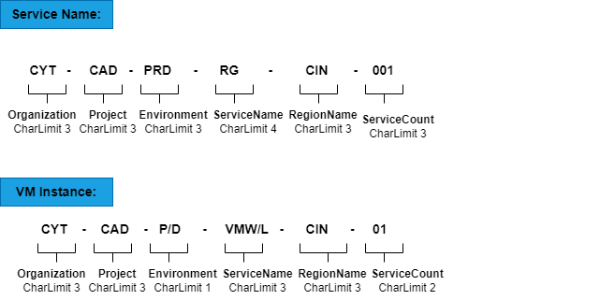

Diagram that shows the components of an Azure resource name.

Below sample documentation was done as per the Microsoft doc, attached below link for reference.

|  |  |  |
| --- | --- | --- |
| **Resource type** | **Resource name prefix** | **Examples** |
| Resource group | org-proj-env-rg-location-001 | CY-CADM-DEV-RG-CIN-001 |
| Virtual network | org-proj-env-vnet-location-001 | CY-CADM-DEV-VNET-CIN-001 |
| Virtual network gateway | org-proj-env-vn-gw-location-001 | CY-CADM-DEV-VNET-GW-CIN-001 |
| Gateway connection | org-proj-env-cn-location-001 | CY-CADM-DEV-CN-CIN-001 |
| Subnet | org-proj-env-snet-location-001 | CY-CADM-DEV-SNET-CIN-001 |
| NSG | org-proj-env-nsg-location-001 | CY-CADM-DEV-NSG-CIN-001 |
| Virtual machines | orgprojenvvmlocation001 | CYCADMDEVVMWCIN001, CYCADMEVVMLCIN001 [vmw-windows, vml-Linux] |
| VM storage account | orgprojenvstvmlocation-001 | CYCADMDEVSTVMCIN001 |
| Public IP | org-proj-env-pip-location-001 | CY-CADM-DEV-PIP-CIN-001 |

[Define your naming convention - Cloud Adoption Framework | Microsoft Docs](https://docs.microsoft.com/en-us/azure/cloud-adoption-framework/ready/azure-best-practices/resource-naming)